Anjuman Hami-E-Muslimeen’s
Anjuman Arts, Science, Commerce College & P.G. Centre, BHATKAL, 581320,
North Kanara, Karnataka.

The Annual Quality Assurance Report (AQAR) of the IQAC
For the year 2011-12

SUBMITTED TO

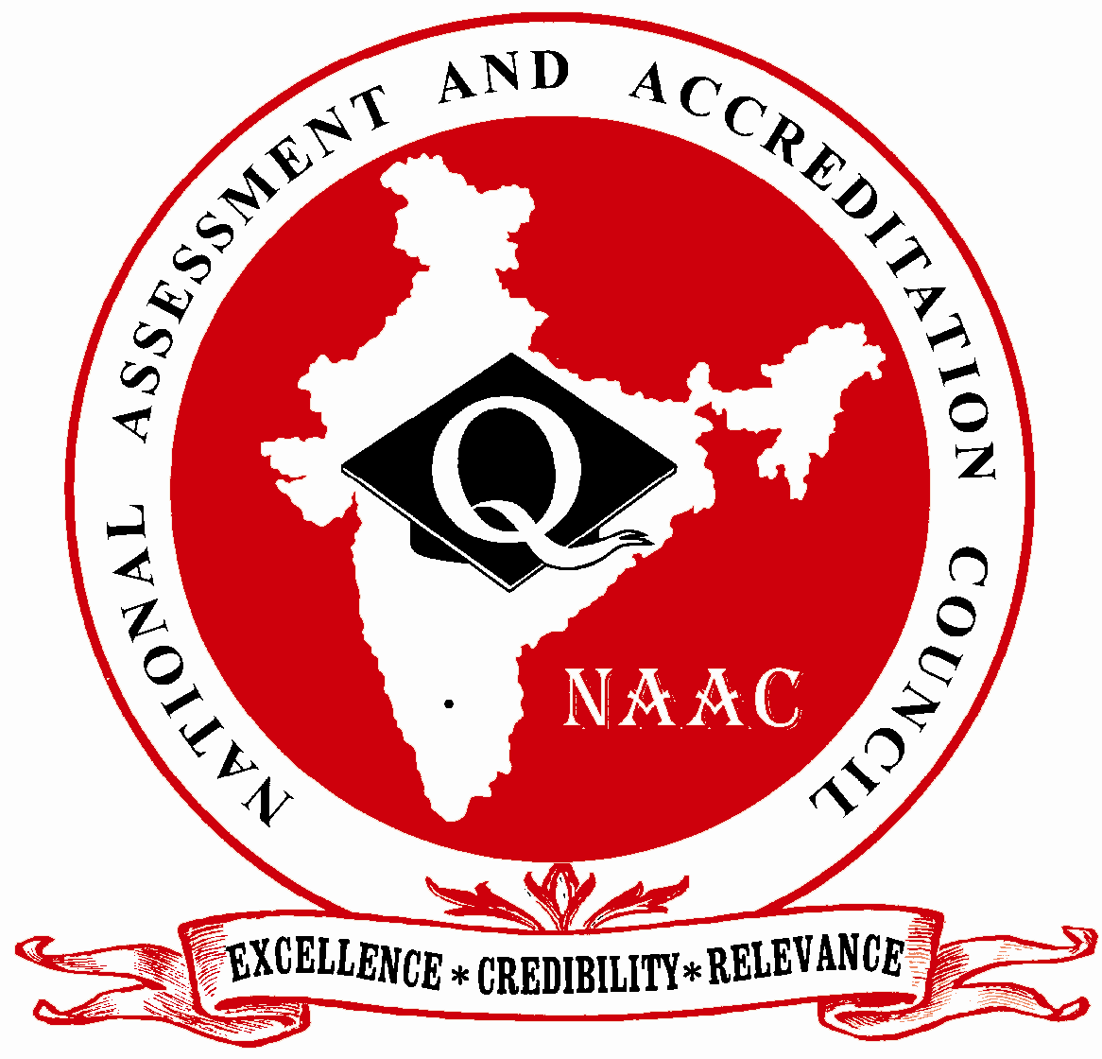

NATIONAL ASSESSMENT AND ACCREDITATION COUNCIL
An Autonomous Institution of the University Grants Commission
P. O. Box. No. 1075, Opp: NLSIU, Nagarbhavi, Bangalore - 560 072 India

The Annual Quality Assurance Report (AQAR) of the IQAC

Part – A
1. Details of the Institution
Anjuman Arts, Science Commerce Commege College & P.G. Centre Bhatkal
1.1 Name of the Institution
Anjumanabad Bhatkal
1.2 Address Line 1

Address Line 2
Bhatkal
City/Town
Karnataka
State
581320
Pin Code
anjumancollegebkl@gmail.com
Institution e-mail address
08385-226443
Contact Nos.
Dr. Syed Zameerulla Sharief (Rtd)
Dr. K.C. Nazeer Ahmed (old)
Prof. A.M.Mulla - Present

Name of the Head of the Institution:
08385 226443
Tel. No. with STD Code:
9845578852
Mobile:

Prof. A.M.Mulla (old)
Prof. M.M.Jamadar – Present
Name of the IQAC Co-ordinator:
9845813162
Mobile:
anjumancollegebkl@gmail.com
IQAC e-mail address:
42nd EC/March 31,2007/206

1.3 NAAC Track ID (For ex. MHCOGN 18879)

1.4 NAAC Executive Committee No. & Date:
42nd EC/March 31,2007/206

(For Example EC/32/A&A/143 dated 3-5-2004.
This EC no. is available in the right corner- bottom
of your institution’s Accreditation Certificate)

www.adc.ac.in
1.5 Website address:
http://www.adc.ac.in/AQAR2011-12.doc

Web-link of the AQAR:
For ex. http://www.ladykeanecollege.edu.in/AQAR2012-13.doc
1.6 Accreditation Details
Sl. No. | Cycle | Grade | CGPA | Year of Accreditation | Validity Period
1 | 1st Cycle | B | - | 2007 | 5 years
2 | 2nd Cycle | - | - | - | -
3 | 3rd Cycle | - | - | - | -
4 | 4th Cycle | - | - | - | -

1.7 Date of Establishment of IQAC : DD/MM/YYYY
21/12/2005

2011-12
1.8 AQAR for the year (for example 2010-11)

1.9 Details of the previous year’s AQAR submitted to NAAC after the latest Assessment and Accreditation by NAAC ((for example AQAR 2010-11submitted to NAAC on 12-10-2011)
- AQAR 2008-09 06/07/2009
- AQAR 2009-10 03-12-2014
- AQAR 2010-11 03-12-2014

1.10 Institutional Status


University State Central Deemed Private


Affiliated College Yes No
Constituent College Yes No



Autonomous college of UGC Yes No





Regulatory Agency approved Institution Yes No
(eg. AICTE, BCI, MCI, PCI, NCI)


Type of Institution Co-education Men Women


Urban Rural Tribal





Financial Status Grant-in-aid UGC 2(f) UGC 12B

Grant-in-aid + Self Financing Totally Self-financing


1.11 Type of Faculty/Programme


Arts Science Commerce Law PEI (Phys Edu)




TEI (Edu) Engineering Health Science Management

M.A Kannada, PGDCA, M.Com
Others (Specify)

1.12 Name of the Affiliating University (for the Colleges)
Karnatak University, Dharwad

1.13 Special status conferred by Central/ State Government-- UGC/CSIR/DST/DBT/ICMR etc
No
Autonomy by State/Central Govt. / University
No
No
University with Potential for Excellence UGC-CPE

---
---
DST Star Scheme UGC-CE
---
---
UGC-Special Assistance Programme DST-FIST
---
---
UGC-Innovative PG programmes Any other (Specify)
---
UGC-COP Programmes
2. IQAC Composition and Activities
10
2.1 No. of Teachers
02
2.2 No. of Administrative/Technical staff
---
2.3 No. of students
2.4 No. of Management representatives
02
03
2.5 No. of Alumni
2. 6 No. of any other stakeholder and
02
community representatives
01
2.7 No. of Employers/ Industrialists
-
2.8 No. of other External Experts
2.9 Total No. of members
21
02
2.10 No. of IQAC meetings held
2
03
2.11 No. of meetings with various stakeholders: No. Faculty
03
01
05
Non-Teaching Staff Students Alumni Others

2.12 Has IQAC received any funding from UGC during the year? Yes No
----


If yes, mention the amount

2.13 Seminars and Conferences (only quality related)
(i) No. of Seminars/Conferences/ Workshops/Symposia organized by the IQAC
03
1
1
1
-
Total Nos. International National State Institution Level

(ii) Themes
- Int. Sem- Global Employability – Challenges & Prospects on 24-07-2011
- Nat. Sem- Moulana Abul Kalam Azad’s Life & Contribution on 04-03-2012
- One Day Teachers Training Workshop “Train The Trainer” on 19-01-2012

2.14 Significant Activities and contributions made by IQAC
IQAC was established on 21-12-2005 after the first Assessment and Accreditation of the College. The IQAC is established with implementing several quality assurance and sustenance mechanism, to monitor and evaluate the outcome of the quality processes adopted.
The IQAC has been working as a facilitative and participative unit in overall performance of the institution’s academic and administrative tasks towards quality enhancement and sustenance. It channelizes all efforts and measures to ensure efficient and effective performance of the various parameters to internalize quality culture and best practices.
The IQAC works with various committees in the realisation of the goals and objectives:
The IQAC regularly meets the College Board Secretary and also the General Secretary and briefs them about the work/activities completed and to be carried out.
It Co-ordinates with the College Function Committee, Attendance Committee, Exam Committee, Library Committee, Mentoring Committee, Magazine committee, Career Guidance & Counselling Cell, Research Cell & other Units - The NSS, NCC, The Student Welfare Wing of the college and extends all support and co-operation.
The principal communicates to the IQAC the policies and plans of the College Board decision and the set objective to be attained during the academic year. He also gives the details of orders and circulars received from Department of Collegiate Education, University and the UGC Guidelines to be implemented.
The IQAC has successfully organized/conducted Seminars/Workshops/ Resource Lectures/Fest as per the college academic calendar. The IQAC makes necessary recommendations to the principal regarding infrastructure development & maintenance. It has taken initiatives in promoting quality teaching - learning methods in theory and practice and internalizing quality culture, best practices and optimum use of ICT resources.
IQAC has made recommendations to the principal regarding library requirements, lab equipments & sports material to be purchased under UGC funds. It ensures that students support and progression is strengthened and monitored at all levels.

2.15 Plan of Action by IQAC/Outcome
The plan of action chalked out by the IQAC in the beginning of the year towards quality
enhancement and the outcome achieved by the end of the year 2011-12
Plan of Action | Achievements
- To prepare Annual calendar for organising events and activities.  - Optimum utilisation of available ICT resources in teaching – learning.  - To organise two National Level Seminars and three State Level/College Level.  - To conduct three lectures on relevant topics by inviting resource persons.  - To organise a National Level fest in our college during academic year  - To conduct a Teachers Training Workshop during the academic year.  - To conduct Internal Test & Home Assignments for All classes  - To utilize the UGC grants for purchasing Lab Equipments & Chemicals, ICT material, UPS, Notice Boards, CC TV Cameras.  - Maintenance work - To repair the damaged furniture, class room chairs, tables, doors, windows.  - To take feedback on library books needed for students and faculty and take necessary follow-up action.  - To compile the Dissertation Abstracts of the PG students & document them in the library & send one copy to the University | - College Annual calendar was prepared & implemented.  - Faculty have made use of all available ICT facilities in teaching learning.  - Successfully organised One National Level seminar on 4th March 2012.  - We conducted One Lecture by Resource Persons ( Chartered Accountants)  - A National Level Fest was organised on 11th & 12th February 2012.  - Successfully organised/conducted a Two Day Teachers Training Workshop “Train the Trainer” on 19th & 20th January 2012  - I.A Tests & Home Assignment were conducted as per schedule  - All the Items mentioned were purchased as per UGC guidelines. Audit receipts were sent to the UGC office.  - Maintenance and repair work was carried out and an amount of Rs.33150/- was spent  - Need based books were bought for the college library.  - Dissertation Abstracts of the PG students were compiled and documented.
* Attach the Academic Calendar of the year as Annexure.
2.15 Whether the AQAR was placed in statutory body Yes No




Management Syndicate Any other body
Provide the details of the action taken
- All the recommendations and suggestions made by the IQAC in the IQAR were placed in the College Board Meeting and the Management approved the same.
- Infrastructure requirements, student - centric teaching-learning, academic programmes and activities.
- Items to be purchased under the UGC grant funds, conducting of seminars/ lecturer by resource persons, library – books and other requirements.
- Co-curricular activities, sports – track/field events/ Annual Sports Day and Annual Social Gathering were conducted.

Part – B
Criterion – I

1. Curricular Aspects

1.1 Details about Academic Programmes
Level of the Programme | Number of existing Programmes | Number of programmes added during the year | Number of self-financing programmes | Number of value added / Career Oriented programmes
PhD | - | - | - | -
PG | 02 | - | 02 | -
UG | 03 | - | - | -
PG Diploma | 01 | - | 01 | -
Advanced Diploma | - | - | - | -
Diploma | - | - | - | -
Certificate | - | - | - | -
Others | - | - | - | -
Total | 06 | - | 03 | -

Interdisciplinary | - | - | - | -
Innovative | - | - | - | -

1.2 (i) Flexibility of the Curriculum: CBCS/Core/Elective option / Open options
(ii) Pattern of programmes:
Pattern | Number of programmes
Semester | 06
Trimester | -
Annual | -





-



1.3 Feedback from stakeholders* Alumni Parents Employers Students
(On all aspects)



Mode of feedback : Online Manual Co-operating schools (for PEI)
*Please provide an analysis of the feedback in the Annexure

1.4 Whether there is any revision/update of regulation or syllabi, if yes, mention their salient aspects.
B.Com Syllabus subjects, Languages

1.5 Any new Department/Centre introduced during the year. If yes, give details.
No

Criterion – II
2. Teaching, Learning and Evaluation
2.1 Total No. of permanent faculty
Total | Asst. Professors | Associate Professors | Professors | Others
18 | 03 | 13 | - | 02
03
2.2 No. of permanent faculty with Ph.D.
2.3 No. of Faculty Positions Recruited (R) and Vacant (V) during the year
Asst. Professors |  | Associate Professors |  | Professors |  | Others |  | Total
R | V | R | V | R | V | R | V | R | V
- | 2 | - | - | - | - | - | - | - | 2
4
-
15
2.4 No. of Guest and Visiting faculty and Temporary faculty

2.5 Faculty participation in conferences and symposia:
No. of Faculty | International level | National level | State level
Attended Seminars/ Workshops | - | 1 | -
Presented papers | - | - | -
Resource Persons | - | - | 2

2.6 Innovative processes adopted by the institution in Teaching and Learning:
- Faculty uses all ICT facilities – Computer, Internet, E-Library, Smart Boards, Projectors, and Laptops. Staff are given full freedom to use innovative teaching best suited to them taking in consideration the academic needs of the students.
- Interactive and participative approach in teaching learning is encouraged.
- Students have access to all the facilities mentioned above. Students make use of computers internet and E-library in presenting their seminar & preparing project work etc.

2.7 Total No. of actual teaching days
180
during this academic year
2.8 Examination/ Evaluation Reforms initiated by
the Institution (for example: Open Book Examination, Bar Coding,
Double Valuation, Photocopy, Online Multiple Choice Questions)
Internal Assessment Tests are conducted by the exam committee, Home Assignments in each subject is given by the concerned teacher and valued by them. Semester exams are conducted by the University.

2.9 No. of faculty members involved in curriculum
1
restructuring/revision/syllabus development
as member of Board of Study/Faculty/Curriculum Development workshop
77%
2.10 Average percentage of attendance of students

2.11 Course/Programme wise distribution of pass percentage :
Title of the Programme | Total no. of students appeared | Division
Title of the Programme | Total no. of students appeared | Distinction % | I % | II % | III % | Pass %
B.A V Sem | 16 | 13 | 02 | 01 | - | 100%
B.Sc. V Sem | 25 | 11 | 05 | 02 | - | 72%
B.Com V Sem | 109 | 16 | 21 | 18 | 01 | 51.37%

2.12 How does IQAC Contribute/Monitor/Evaluate the Teaching & Learning processes :
- To prepare calendar of events in the beginning of the academic year.
- To make recommendation to the principal to recruit required faculty
- To encourage staff to make use of innovative teaching methods and to use ICT facilities whenever necessary.
- To arrange for special lecturers on relevant topics – Personality Development, Communication Skills, Subject Specific Topics by inviting Resource Persons.
- To organise Seminar/ Conference/ Workshop/ Fest/ Special Lecture on the relevant topics decided in the staff meeting that would benefit both the staff and the students.
- To review the results of each semester of all the classes and identify the weak students and conduct extra classes for them.
- To issue letter of appreciation to those members of faculty with excellent results.
- To analyse the students feedback and mentoring records received and make necessary recommendations to the principal regarding academic requirements/ difficulties of the students
2.13 Initiatives undertaken towards faculty development
Faculty / Staff Development Programmes | Number of faculty  benefitted
Refresher courses | -
UGC – Faculty Improvement Programme | -
HRD programmes | -
Orientation programmes | -
Faculty exchange programme | -
Staff training conducted by the university | -
Staff training conducted by other institutions | -
Summer / Winter schools, Workshops, etc. | -
Others | -
2.14 Details of Administrative and Technical staff
Category | Number of Permanent  Employees | Number of Vacant  Positions | Number of permanent positions filled during the Year | Number of positions filled temporarily
Administrative Staff | 05 | 17 | Nil | Nil
Technical Staff | - | - | - | 01

Criterion – III
3. Research, Consultancy and Extension
3.1 Initiatives of the IQAC in Sensitizing/Promoting Research Climate in the institution
IQAC has established a Research Cell in our college. The Research Cell has been actively involved in motivating & encouraging the members of faculty/ students to take up research activity/work. The members of the cell are all Ph.D holders and deliver special lectures and guidance on research methodology, research materials availability options. The faculty handling M.A/M.Com/PGDCA Classes assign the students ‘Project Work’ as part of regular academic activity in order to make the students aware about importance of research, its benefits and develop an approach and attitude of scientific temper. The Research Cell takes the initiative to invite resource persons to help the aspiring potential candidates to undertake research work during the academic year 2011-12. The Research Cell has organised/conducted 06 lecturers for members of faculty and 04 for M.A/M.Com students. The research cell makes recommendations to IQAC to provide/arrange for Internet facilities, Library Books, Lab facilities, at subsidized rates to those associated/ involved in research work.
Members of Research Cell :
- Dr. S.Z. Sharief Co-Ordinator
- Dr. K.C. Nazeer Ahmed Member
- Dr. S.R. Usmani Member
- Dr. N. Madhyasta Member
- Dr. Suresh Naik Member

3.2 Details regarding major projects
 | Completed | Ongoing | Sanctioned | Submitted
Number | - | - | - | -
Outlay in Rs. Lakhs | - | - | - | -

3.3 Details regarding minor projects
 | Completed | Ongoing | Sanctioned | Submitted
Number | - | - | 02 | -
Outlay in Rs. Lakhs | - | - | Rs.20,000 +  Rs.1,70,000 | -

3.4 Details on research publications
 | International | National | Others
Peer Review Journals | - | - | -
Non-Peer Review Journals | - | - | -
e-Journals | - | - | -
Conference proceedings | - | 01 | -

3.5 Details on Impact factor of publications:
-

-

-

-

Range Average h-index Nos. in SCOPUS
3.6 Research funds sanctioned and received from various funding agencies, industry and other organisations
Nature of the Project | Duration  Year | Name of the  funding Agency | Total grant  sanctioned | Received
Major projects | - | - | - | -
Minor Projects | 2011-12 | UGC | Rs.190000/- | Rs.173000/-
Interdisciplinary Projects | - | - | - | -
Industry sponsored | - | - | - | -
Projects sponsored by the University/ College | - | - | - | -
Students research projects  (other than compulsory by the University) | - | - | - | -
Any other(Specify) | - | - | - | -
Total | - | - | - | -

01
3.7 No. of books published i) With ISBN No.
-
Chapters in Edited Books
-
ii) Without ISBN No.
3.8 No. of University Departments receiving funds from
UGC-SAP CAS DST-FIST
-
-
-
-
-
DPE DBT Scheme/funds
3.9 For colleges Autonomy CPE DBT Star Scheme
-
-
-
INSPIRE CE Any Other (specify)
-
-
-

3.10 Revenue generated through consultancy
Nill

3.11 No. of conferences organized by the Institution
Level | International | National | State | University | College
Number | - | 01 | - | - | 01
Sponsoring agencies | - | Local Donors & Dept of Urdu Anjuman Degree College & P.G. Centre Bhatkal | - | - | -

3.12 No. of faculty served as experts, chairpersons or resource persons
04
-
-
-
3.13 No. of collaborations International National Any other
-
3.14 No. of linkages created during this year

3.15 Total budget for research for current year in lakhs :
Rs.15000+ Rs.158000
-
From Funding agency From Management of University/College
Rs.173000
Total

3.16 No. of patents received this year
Type of Patent |  | Number
National | Applied | -
National | Granted | -
International | Applied | -
International | Granted | -
Commercialised | Applied | -
Commercialised | Granted | -

3.17 No. of research awards/ recognitions received by faculty and research fellows
Of the institute in the year
Total | International | National | State | University | Dist | College
- | - | 01 | - | - | - | -

3.18 No. of faculty from the Institution
01
who are Ph. D. Guides
and students registered under them
-

3.19 No. of Ph.D. awarded by faculty from the Institution
-

3.20 No. of Research scholars receiving the Fellowships (Newly enrolled + existing ones)
-
-
JRF SRF Project Fellows Any other
-
-
3.21 No. of students Participated in NSS events:
-
-
University level State level
National level International level
-
-
3.22 No. of students participated in NCC events:
55
01
University level State level
National level International level
-
-
3.23 No. of Awards won in NSS:
-
-
University level State level
-
-
National level International level
3.24 No. of Awards won in NCC:
-
-
University level State level
-
-
National level International level
3.25 No. of Extension activities organized
-
-
University forum College forum
1
3
-
NCC NSS Any other

3.26 Major Activities during the year in the sphere of extension activities and Institutional Social Responsibility
- Principal Dr. S.Z.Sharief was invited as a resource person, organized by Kannada & Cultural Department Uttara Kannada. On the Topic “Women and culture camp for thought”.
- Seven Day NSS Camp was organised at Govt. Higher Primary School Tengingundi, Bhatkal- campus cleaning, planting tree saplings, lectures by resources persons and scholars on importance of social service, nation building, secularism and other important topics.
- Vice Principal Prof. M.M.Jamadar HOD of English was invited to deliver a guest lecture on the theme “Importance of English Language For Teachers as Communicators” at Anjuman College of Education Bhatkal.
- Dr. S.R. Usmani HOD of Urdu was invited as a resource person by DEO Karwar at the Orientation Program for Urdu teachers. He was also invited to preside over the Multilingual State Level Mushaira on National Integration held at Karwar.

Criterion – IV
4. Infrastructure and Learning Resources
4.1 Details of increase in infrastructure facilities:
Facilities | Existing | Newly created | Source of Fund | Total
Campus area | 50 | - | Management | 50 Acres
Class rooms | 15 | - | Management | 15
Laboratories | 06 | - | Management | 06
Seminar Halls | 1 | - | Management | 01
No. of important equipments purchased (≥ 1-0 lakh) during the current year. | 16 | 05 | UGC | 21
Value of the equipment purchased during the year (Rs. in Lakhs) | 366462 | 15447 | UGC | 381909
Others | 185904 | 24026 | UGC | 209930

4.2 Computerization of administration and library
Four Computers with Internet facilities are provided to the Office and one computer for Principal for administration related work. A laptop is also available in the Principals chamber for necessary academic/office work.
The Library is provided with computer and Internet facility. E-Library with Internet facility INFLIBNET N-LIST Ahmadabad, Gujarat. UGC sponsored for Staff, U.G. & P.G. students. The IQAC has made a recommendation for Library Automation.

4.3 Library services:
 | Existing |  | Newly added |  | Total
 | No. | Value | No. | Value | No. | Value
Text Books | 22914 | 1139180 | 355 | 99823 | 23269 | 1239003
Reference Books | 2003 | 275840 | 214 | 44935 | 2217 | 3020775
e-Books | 51000 | 5000* | - | - | 51000 | 5000*
Journals | 17 | 1350 | 01 | 2020 | 18 | 15170
e-Journals | 2100 | 5000* | - | - | 2100 | 5000*
Digital Database | N-LIST | 5000* | N-LIST | - | N-LIST | 5000*
CD & Video | 50 | - | - | - | 50 | -
Others (specify) | - | - | - | - | - | -
Note: * is related to the total amount inclusive of E-Books, E-Journals & Digital Database

4.4 Technology up gradation (overall)
 | Total Computers | Computer Labs | Internet | Browsing Centres | Computer Centres | Office | Depart-ments | Others
Existing | 51 | 02 | 04 | 01 | - | 01 | 04 | 01
Added | 10 | - | - | - | - | - | - | -
Total | 61 | 02 | 04 | 01 | - | 01 | 04 | 01

4.5 Computer, Internet access, training to teachers and students and any other programme for technology
upgradation (Networking, e-Governance etc.)
We have Networking facility of all the computers – Principal Chamber - Computer Labs – Office Computers – Staff Room Computer

4.6 Amount spent on maintenance in lakhs :
9, 95,262/-
i) ICT
92,864/-
ii) Campus Infrastructure and facilities
9, 30,137/-
iii) Equipments
72,511/-
iv) Others

20, 90,774/-
Total :

Criterion – V
5. Student Support and Progression
5.1 Contribution of IQAC in enhancing awareness about Student Support Services
STUDENT SUPPORT SERVICES
- To create awareness regarding Scholarship, Fee Concession, Employment information, Exams, Programmes, – Academic Co-curricular, Sports competition and student related information of other departments is up-loaded in the college website.
- The information is also available in the college prospectus. We also display all this information on the college notice board. The same notices are circulated to be read in each class room for the information and benefit of the students.
- The IQAC and SWO co-ordinate and arrange special lectures by resource persons on various topics. The Assistant Placement Officer of our college gives all help and special training for students for campus interviews and for participation in other competitions.
- The sports department makes arrangements to give special coaching/training to outstanding sports persons to participate and qualify in the University Level/State level/National Level teams.
- The Career Guidance and Counselling Cell and Mentoring Committee have been extending support to all the students in general and particularly to those who are facing difficulties due to some social economic emotional or psychological reasons.
- A separate students vehicle parking facility a Watchman has been appointed to take care of students vehicles.
- Refreshment/Lunch is available to the students in the college canteen at subsidised rates.
- We have Book Bank facility in our library for UG & P.G. Students. We are planning to introduced Merit Based Library Card for meritorious students.
- Members of the management visit the classes to counsel and motivate the students in their academic and non-academic .The Secretary of the college board is accessible to the students on every Thursday for interaction.

5.2 Efforts made by the institution for tracking the progression
- The Attendance committee maintains records every month and it’s submitted to the college office. List of students with shortage of attendance is displayed on the notice board and parents are informed about it through letters of over telephone
- The results of Internal Assessment Tests are brought to the notice of the students by concerned teachers. Teachers help the weak students to improve.
- University results of the semester exams are reviewed in College Board meeting staff meetings, principal and HOD meetings. The staffs whose results are not satisfactory are motivated for improvements.
- To encourage and motivate students for participation in college activities – curricular, Co-curricular, NCC, NSS and Sports etc.
- Mentoring committees are formed to counsel and help the students in their studies, personality development, good results in the exams, moral and social values and career building.
- Parent- teacher meets are also helps to identify the general problems of the students and give necessary guidance and help.

UG | PG | Ph. D. | Others
476 | 65 | - | -
5.3 (a) Total Number of students

(b) No. of students outside the state
-
-

(c) No. of international students

No | %
523 | 97%
Men Women
No | %
18 | 3
Last Year 2010-11 |  |  |  |  |  | This Year 2011-12
General | SC | ST | OBC | Physically Challenged | Total | General | SC | ST | OBC | Physically Challenged | Total
6 | 7 | 12 | 468 | - | 493 | 10 | 09 | 11 | 446 | - | 476
Demand ratio - 100% Dropout - 02%

5.4 Details of student support mechanism for coaching for competitive examinations (If any)
- We are not giving regular coaching for competitive exams, we help them by displaying on the notices boards the information /advertisements regarding competitive exams.
- Students interested in appearing for competitive exams can borrow the books and magazines, journals etc from the library on subscription.
- NCC unit of our college displays all information regarding defence service examinations and briefs the cadets during their regular training parades.
- Necessary help is given to the students by the concerned faculty members who approach them.

476
No. of students beneficiaries

5.5 No. of students qualified in these examinations
-
-
-
-
NET SET/SLET GATE CAT
IAS/IPS etc State PSC UPSC Others
-
-
-
-

\
5.6 Details of student counselling and career guidance
- Students are counselled at the time of admission by the principal and attendance committee taking into consideration their previous performance to make right selection of the course.
- In the beginning of the academic year all the teachers counsel students in the classes about the semester pattern, examinations, facilities available - Library, Labs, Sports, NCC, NSS etc..
- In addition to this we have a Career Guidance & Counselling Cell. Students can approach the Co-ordinator/Members with their difficulties and problems & seek necessary help and guidance.
- Students are also free to approach the Principal, Vice Principal, College Board Secretary and other staff members for assistance and guidance.

476
No. of students benefitted

5.7 Details of campus placement
On campus |  |  | Off Campus
Number of Organizations Visited | Number of Students Participated | Number of Students Placed | Number of Students Placed
- | - | - | 01

5.8 Details of gender sensitization programmes
We conducted 07 days NSS camp in which resource persons gave lectures on various topics that would beneficial in gender sensitization – Role of Youth in Nation Building, Women Empowerment, Anti Dowry, Personality Development and Social Equality Reservation Policies etc.

5.9 Students Activities
5.9.1 No. of students participated in Sports, Games and other events
32
-
-
State/ University level National level International level

No. of students participated in cultural events
17
01
-
State/ University level National level International level

5.9.2 No. of medals /awards won by students in Sports, Games and other events
-
-
01
Sports : State/ University level National level International level
01
-
-
Cultural: State/ University level National level International level

5.10 Scholarships and Financial Support
 | Number of  students | Amount
Financial support from institution | 04 | 20000
Financial support from government | 19 | 34000
Financial support from other sources | - | -
Number of students who received International/ National recognitions | - | -

5.11 Student organised / initiatives
-
-
-
Fairs : State/ University level National level International level
-
-
-
Exhibition: State/ University level National level International level
-
5.12 No. of social initiatives undertaken by the students

5.13 Major grievances of students (if any) redressed:
There were no major grievances during academic year. However minor grievances like water filter cooler was not working, clash in the academic time – table, students request for more copies of their text books, regular cleaning of the students toilets. To provide for more fans in the class rooms were solved accept of having more fans. Request for having more fans is under consideration.

Criterion – VI
6. Governance, Leadership and Management
6.1 State the Vision and Mission of the institution
OUR VISION
- To develop this college into a premier Institution of Higher Education and be an active component of National Educational System.
- To interact with institutions of Higher Education and other organizations those have similar interests and goals.
- To develop human resource of high caliber that is nationally comparable and internationally acceptable with the counterparts, which will empower our students to cope with competitive needs in the changing global scenario.
- To work for the Educational Empowerment of our students by imparting knowledge, skills, moral values and attitude.
- To be efficient, effective, community acceptable and excel in education and service.
- To induce paradigm shift in region and community that education is pre-requisite for human development.
- To reach the unreached and serve the unserved with education.
- To propagate scientific temper, liberalism and humanism.

OUR MISSION
- To cater to the Educational needs of Bhatkal and surrounding areas.
- To induce knowledge that fosters self-learning and continuous improvement.
- To impart value based quality education and develop adaptability skills.
- To strive for academic and extra curricular excellence through quality, efficiency, innovation and continuous improvement in all the processes of our system.
- To develop professionalism in Education, Management, Service and work for stakeholder’s satisfaction.
- To develop strong community relationship, foster good-will and co-operation among all sections of students.
- To develop leadership qualities, patriotism and commitment to contribute to National development.
- To promote the use of Scientific Technology and Communication Technology in the delivery of education.

Yes

6.2 Does the Institution has a Management Information System
6.3 Quality improvement strategies adopted by the institution for each of the following:
6.3.1 Curriculum Development
Our college is a degree college affiliated to Karnatak University Dharwad. In the semester pattern of education the University prescribes the syllabus & subjects. The BOS invites senior faculty members for framing/designing the syllabus. Workshops are also conducted by the University to review the existing syllabus and to make necessary changes if required. The curriculum prescribed by the University is taught in the college as per the academic calendar and work distribution.

6.3.2 Teaching and Learning
The strategy and approaches adopted by the teachers in the delivery of education is learner – centric, innovative methods of pedagogy are adopted in imparting quality education. The institution strives to provide necessary Knowledge, Skills, Attitude to the students to face the Global Challenges and become responsible citizens.

6.3.3 Examination and Evaluation
In the semester pattern of education the University conducts the semester exam of 80 marks in theory at the end of every term. In each academic year the students write two semester exams at the college level. We conduct two Internal Assessment Tests of 20 marks each and home assignments of 20 marks which will be aggregated and reduced to an average total of 20 marks. Evaluation of 80 marks theory papers is done at University central valuation camps.

6.3.4 Research and Development
In order to promote research related activities, publications and academic development we have formed Research Cell. The Research Cell Co-ordinates with the members of the staff. The committee encourages and motivates aspiring members of the staff engaged in research and also those who are interested in research & development work. The Research Cell makes recommendations for necessary academic/financial help to the scholars

6.3.5 Library, ICT and physical infrastructure / instrumentation
We have two computer labs with Internet facilities for UG & PG separately. Students and staff have access to the labs during college hours. We have installed 14 computers in the Library and we have availed e-library package for all students. Our library is well stacked with books, magazines, journals and regular news papers. Proposal to install automation facilities to the library under UGC funds has been placed before the principal and management for consideration and clearance. Proposal submitted to management for construction of 4 class rooms with necessary furniture’s and other academic requirements is under consideration. Necessary Lab instruments and equipments are purchased regularly as when HOD’s of all departments make recommendations under we have utilized UGC funds worth Rs.9,30,137/- for equipments and chemicals for the academic year 2011-12.

6.3.6 Human Resource Management
The Principal in consultation with HOD’s collects information about work-load and other academic requirements of the departments. Plans are worked out regarding the distribution of work among the existing approved and unapproved staff for smooth and effective implementation of strategies.

6.3.7 Faculty and Staff recruitment
Department of Collegiate Education has stopped approvals due to economy major imposed by Government.
However at the beginning of the academic year HOD’s of each department submit individual and departmental work-load and requirements to the principal. In the college board meeting the principal places the staff requirement teaching and non-teaching to be filled of immediately. Advertisement for vacancies is given in the national and regional news papers. Oral interviews are conducted in which subject experts, management members, principal and HOD’s are present. The selected candidates after clearing the oral interview should also clear the demo interview.
Faculty from sister institutions of Anjuman are also invited as visiting faculty depending on the need/availability and honorarium is paid to them. As of now we have 19 - teaching and 07 non-teaching management paid employees working in our college.

No

6.3.8 Industry Interaction / Collaboration
6.3.9 Admission of Students
We are giving admission to all the students who are eligible irrespective of caste, creed or colour. Students are admitted as per the norms of Karnataka University, Dharwad.

Teaching | ---
Non teaching | ---
Students | ---

6.4 Welfare schemes for

---
6.5 Total corpus fund generated


6.6 Whether annual financial audit has been done Yes No

6.7 Whether Academic and Administrative Audit (AAA) has been done?
Audit Type | External |  | Internal
Audit Type | Yes/No | Agency | Yes/No | Authority
Academic | Yes | Agency | Yes | Authority
Administrative | Yes | Agency | Yes | Authority

6.8 Does the University/ Autonomous College declares results within 30 days?


For UG Programmes Yes No


For PG Programmes Yes No
6.9 What efforts are made by the University/ Autonomous College for Examination Reforms?
The university takes care of all examination reforms. Taking into consideration the recommendations of the BOS/ Associations/Forums/ of the students needs the University has introduced compulsory subjects in the combinations like Computer Applications, Personality Development & Communication Skills, Indian Constitution, at Under Graduate level for B.A, B.Sc. & B.Com at different semesters.

6.10 What efforts are made by the University to promote autonomy in the affiliated/constituent colleges?
No efforts are made for autonomy.

6.11 Activities and support from the Alumni Association
The Staff Co-ordinator of Alumni Association and the president are making all efforts in expanding our alumni base. We conduct Alumni Association Meeting once or twice in an academic year. Our Alumni are actively associated in our onward journey and developmental activities & programmes.

6.12 Activities and support from the Parent – Teacher Association
Parents/Guardians are counselled at the time of admission. Parents Meet is held once or twice in an academic year. Problems/difficulties/grievances are discussed and suggestions are welcomed and some are implemented.

6.13 Development programmes for support staff
The office staff are deputed to participate in training/workshop organised/conducted by the DCE/KUD/Management. Special computer coaching is provided for staff at other Anjuman Institutions.

6.14 Initiatives taken by the institution to make the campus eco-friendly
Saplings are planted in the college campus given by Horticulture/Forest department. Gardner is appointed to take care of Botany Garden. NSS volunteers and Red Cross Wing are also involved in campus cleaning program and to make the college campus plastic free zone and banners are pasted at various places on the college campus to create awareness about echo friendly environment.

Criterion – VII
7. Innovations and Best Practices
7.1 Innovations introduced during this academic year which have created a positive impact on the
functioning of the institution. Give details.
Infrastructural Innovations:
- Use of Smart boards, Laptops & Projectors for classroom teaching for UG and PG students.
- Separate UG and PG Computer labs along with one common e-library facility.
Academic Innovations:
- Every Thursday interaction of students with college board secretary i.e. one to one interaction to know the students and their academic problems.
- Regular Special Lectures by Resource Persons and CA's, Entrepreneurs, Industrialists, Sportsmen and Government officials from various departments. are conducted to motivate students and to give exposure to the corporate learning atmosphere. Peer learning is practiced to expand our teaching methodology and knowledge base.
- Mentoring Sessions are conducted by all the teaching staff by taking an allocation of 20 students on an average.
- Student Welfare Wing is also conducting regular career counselling and placement efforts to help students

The quality of education assumes added importance and becomes the primary concern of all the stakeholders in education. All activities conducted during the academic year are linked with the objectives are mentioned in the prescribed prospectus issued to the learners at the beginning of the year. Academic and non-academic activities directly or indirectly reflect the goals and objectives of the institution.
To Impart Quality education and deliver knowledge, skill as prescribed for a particular programme and strive to be efficient effective & adaptable in facilitating teaching/learning and all-round personality development.
To strive for continuous improvement of stake holders towards Professionalism and Competence in transacting syllabus by inviting resource persons, organizing seminars and conducting special lecturers that will be beneficial to the learners to enrich their knowledge
- Providing admission in the available courses to all deserving students, irrespective of caste and creed, so that every student has an opportunity to learn.
- Providing a warm welcome to the fresher’s taking admission and highlighting them on the opportunities available at the institution.
- Involvement of the Parents during the time of admission and creating awareness.
- Honouring the Rank Holders and other distinction performers in academic and non-academic activities.
- Distribution of endowment prizes instituted by local philanthropists.
- Celebration of National Festivals.
- Blood donation camps by the NSS and NCC units of the Institution.
- Conducting of Skill and Personality development programmes.
- Regularly conducting of Seminars, Workshops, by inviting expert & resourceful academicians & Lecturers
- Timely appointment of the required staff.
- Continuous evaluation in the form of unit tests, home assignments, project preparations, etc.
- More attention towards slow learners and encouragement for advanced learners
- Special care and help to poor learners by conducting remedial classes, particularly to students belonging to minority community.
- Participation of students in various higher level curricular and extracurricular competitions.
- Community development oriented special camps by the NSS unit.
- Sports participation at Zonal and Inter-zonal levels and conduct of Inter-zonal Tournament and Annual Athletic Sports.
- Environmental awareness programmes.

7.2 Provide the Action Taken Report (ATR) based on the plan of action decided upon at the
beginning of the year
- The plan of action decided upon at the beginning of the year was carried out successfully with support of the management. The staff of the college has implemented all the activities as per the plan of action and achieved all the expected outcomes as given in 2.15. The students have extended all co-operation in conducting/organizing all the activities, functions & programmes.
- One day National level Seminar was organized by department of Urdu on Moulana Abul Kalam Azad' Life and Contributions.
- Two days Teacher's training workshop-Train the Trainer was organized by department of English.
- All the Items mentioned were purchased as per UGC guidelines. Audit receipts were sent to the UGC office.
- Maintenance and repair work was carried out and an amount of Rs.33150/- was spent
- Need based books were bought for the college library.
- Dissertation Abstracts of the PG students were compiled and documented.
- A National Level Fest-Fuziona 2012 was conducted by the Student Welfare Wing of our college.
- State of art e-library has been installed with more number of e-books and e-journals for the reference and use of staff and students.

7.3 Give two Best Practices of the institution (please see the format in the NAAC Self-study Manuals)
- Our students are invited as Chief Guests and also as Resource Persons for some functions and programmes.
- Students are given training and opportunity to act as Anchors in organising functions/programmes /fests to develop leadership qualities and self confidence.
- We Honour/Felicitate students who secure ranks/highest marks or those who excel in sports – University Blues/State Level/National Level selection by giving special cash prizes, trophies and certificates on Annual Day celebrations
- Assistance to Outside Research Scholars/ Lecturers: In order to help and encourage research related activities , we have provided on request our library, internet/computer, photocopies of materials and other research related help to aspiring scholars of the neighbouring institutions.
- Our management hosts dinner for all the students on farewell function day and also refreshment packets are given to students during seminars/fests organized/conducted in our college.

*Provide the details in annexure (annexure need to be numbered as i, ii,iii)
7.4 Contribution to environmental awareness / protection
- We are regularly participating in tree plantation programs conducted by the forest department and our college units such as NSS.
- We display posters and placards in & outside the College Campus to create awareness of “Clean City And Green City”, stop use of plastic bags pollution free environment.

7.5 Whether environmental audit was conducted? Yes No



7.6 Any other relevant information the institution wishes to add. (for example SWOT Analysis)
Strengths:
- Our College has a sprawling 50 acres of campus
- We have a good library with 26788 number of books (Under Graduate-25585, M.Com-268, M.A Kannada-725, PGDCA-210) along with daily news papers and fortnightly magazines related to various subjects.
- We have e-library facility for the students where we have 55000 e-books and 2500 e-journals.
- The college playground covers an area of 7-acres.
- Adequate infrastructure by way of well ventilated and illuminated lecture rooms .
- We have active Cell of NCC to improve and motivate towards Nation building & self discipline in students.
- Our college is also having Student Welfare Officer to guide student participation in various competitions, activities and Recruitment of students; few are placed by direct appointment immediately prior to and after completion of the degree course.
- Active Cell of NSS cadre to serve the society and economy.
- Strong Teaching-Learning Process. More emphasis on learning in the Teaching Learning Process with teachers as facilitators and mentors.
- All teachers are highly committed, competent, qualified. High retention rate of the faculty members.
- Two Asst. Professors are Ph.D., and few are M.Phil, degree holders. Some of them are doing Ph.D. They are regular contributor of research publications (nationally/ internationally), books.
- The admissions are given to all classes without any discrimination. The Commerce faculty has a remarkable strength.
- The meritorious students get endowment prizes and scholarships given by the well- wishers.
Academic Year | Number of Students | Amount
2011-2012 | 33 | Rs.88,889

- Academic results are quite satisfactory.
- We have good infrastructure facilities for academic learning and excellence, where we have installed Smart boards in most of the class rooms along with projectors.
- Our college has separate computer labs for UG and PG courses.
- Our college maintains good equipments of sports so that students are highly motivated and participative. Hence, we have an excellent record in Athletics and Games at University level.

2011-12 | Mr. Abdul Bari (Captain) | Karnatak University Inter Collegiate University level | Kabaddi | 3rdZonal Championship
- We are regularly organizing and attending Seminars, Workshops and Conferences.
- The best maintenance of the campus, student discipline, value-based educational activities; dynamic service-oriented and committed staff and good results in examinations has earned a good name & reputation for the institution.
Weaknesses:
The following are some of our weaknesses on which we have to improve
- We need additional class rooms for PG.
- We need Conference/PPT Hall & Auditorium.
- There is strength in our Arts and Science courses should improve.
- We need Wi-Fi facility in our college campus.
- There is a need of separate staff rooms faculty-wise.
Opportunities:
- Utilizing our vast campus available, where in we can extend our premises with value added facilities for different courses.
- To appoint faculty having PhD for PG course.
- There is a scope for faculty development programs on a regular basis.
- There is a scope for Gardening and beautification of our campus
- An opportunity to introduce PG courses in Science. (M.Sc in Mathematics, Physics or Chemistry.

Threats:
- As there are no sanctions and approvals from government many talented intellectuals are not taking keen interest in teaching profession.
- Most of the meritorious and brilliant students are attracted towards commerce courses. So the strength of students opting for the studies in Arts, and Science is reduced.
- There is a lack of information systems and database systems which reduces the efficiency in administrative work and correspondence.
- In a small place like Bhatkal there are many colleges in and around, Hence there is a poor admissions in our arts and science department.

8. Plans of institution for next year
- Conducting State level or National level Seminar on Entrepreneurship and its prospects in India.
- The IQAC has recommended for installation of Generator Cable Connection Extention to library, labs and other departments.
- To invite resource persons to deliver lectures on relevant topics.
- Conducting State level or National level Seminar from the department of Urdu.
- Organizing Intra Anjuman competitions for the sister institutions to bring the best talents in one platform.
- Subscribing more E-books and e-journals for the reference of students and staff in e-library.
- To encourage members of faculty for greater participation in community service and extension activities.
- Planned to organize Karnataka University 3rd zone Inter Zonal Table Tennis Tournament.
- To create a balance between theory and practice we have planned to organize Two days Industrial visit for the students.
- To apply for UGC funded Major/Minor research projects.

Name Prof. M.M.Jamadar Name Prof. A.M.Mulla
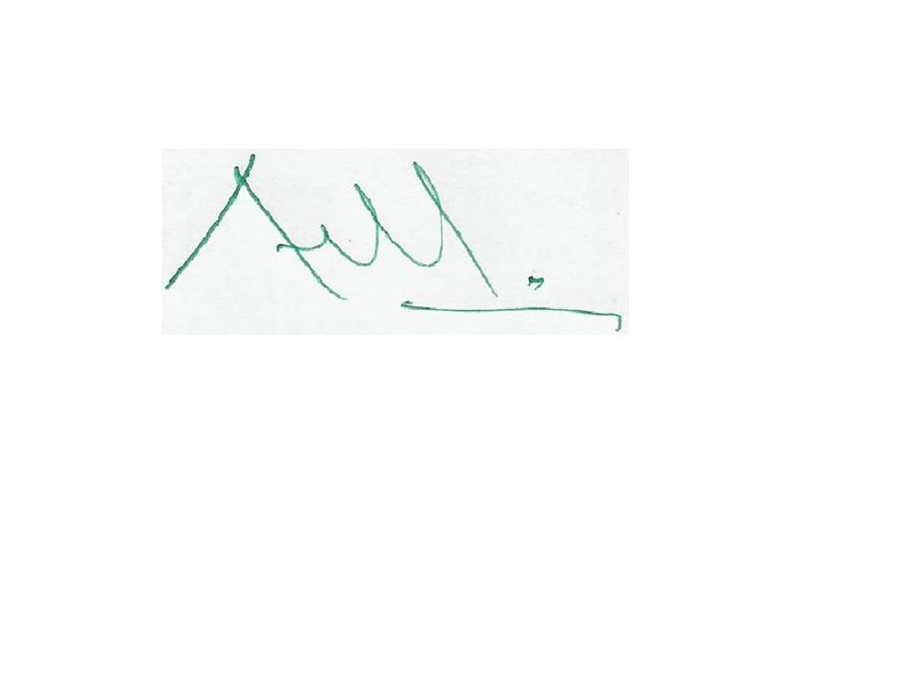
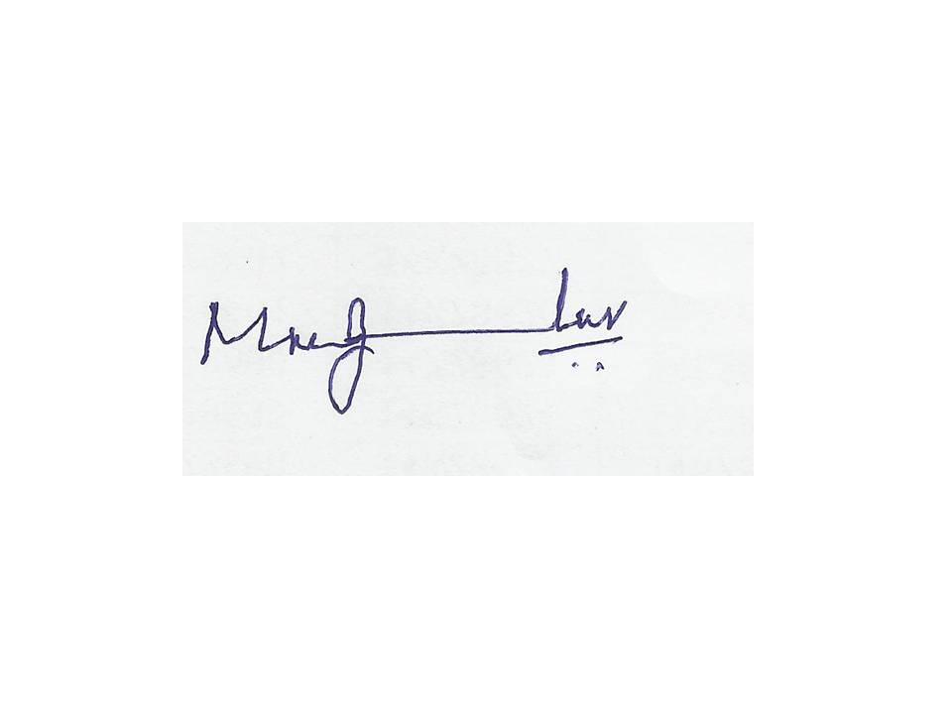

Signature of the Coordinator, IQAC Signature of the Chairperson, IQAC

Annexure I
ANJUMAN ARTS, SCEINCE, COMMERCE COLLEGE & P.G. CENTRE BHATKAL
CALENDAR OF EVENTS FOR THE ACADEMIC YEAR 2011-12
Sl. No | Date | Seminar/Workshops/Functions | Resource persons/Guests/Invitees
01 | 19-07-2011 | To Hold a Staff Meeting | Principal & Staff
02 | 27-07-2011 | Get Together Function (Fresher’s day) | Janab S.M. Syed Khaleelur Rehman Saheb  (President AHM, Bhatkal)
03 | 31-07-2011 | Istiqball –e-Ramzan | Moulana Janab Abdul Bari Saheb & Principal D. S.Z.Sharief
04 | 06-09-2011 to 10-09-2011 | 1st Internal Assessment Test | College Examination Committee
05 | 15-08-2011 | 65th Independence Day Celebration | Principal S.Z.Sharief
06 | 09-10-2011 to 13-10-2011 | 2nd Internal Assessment Test | College Examination Committee
07 | 17-10-2011 | Staff Meeting for semester exams | Principal & Faculty
08 | 26-10-2011 | Last Working Day
09 | 13-12-2011 | Re-Opening of College
10 | 31-12-2011 | Meeting National Level Fest 2012 | Dr. K.C. Nazeer Ahmed Principal & Member
11 | 12-01-2012 | NAAC Committee Meeting | Prof. A.M.Mulla Co-ordinator
12 | 19-01-2012 to 20-01-2012 | Two day teaching Training Workshop | Dr. R.G. Hegde Janab Kashimji Mohammed Ansar Saheb & Janab Siddiqe Ismail Saheb
13 | 19-02-2012 to 23-02-2012 | 1st Internal Assessment Test 2012
14 | 23-01-2012 | Staff & Students Meeting | Janab S.M. Syed Khaleelur Rehman Saheb  (President AHM, Bhatkal)  Janab Abdul Rahim Jukaku Saheb  (general Secretary)
15 | 26-01-2012 | Republic Day ceremony | Principal
16 | 11-02-2012 | National Level Fest 2012 | Dr. Roshan Kazi, Alana Institute of Management.  Dr. H.M. Maheswaraiah, Chairman Department of Kannada, Karnatak University, Dharwad.
17 | 25-02-2012 | NSS Annual Camp | Shri J.D. Naik, M.L.A. Bhatkal
18 | 23-02-2012 | Staff Meeting
19 | 04-03-2012 | One Day National Urdu Seminar | Janab Abdus Samad Samdani, M.L.A. Malapuram, Kerala
20 | 10-03-2012 | Annual Athletic Meet | Janaba Inayatulla Shabandari  President, TMC
21 | 26-03-2012 | Staff Meeting | Principal & Faculty

Annexure II
SPORTS ACTIVITIES- DEPARTMENT OF PHYSICAL EDUCATION

Sports activities from an integral part of student’s career. Our students are enthusiastic sportsmen with zeal and ambition for their best performance. Our students have participated in various Games and Athletic activities conducted by Colleges and University at Zonal and Inter-Zonal level. The following are some of the sports achievements by our students during the academic year 2011-12.

- During the month of December 2011 (from 10th to 12th December) our College Athletic team has participated in Karnatak University Inter Collegiate Athletic Meet 2011-12 at K.U.D. Campus.
- The college has an appreciative team of volleyball, which actively participated in the KUD 3rd Zone Volleyball Tournament (Men 2011-12) held at Honnavar on 12th & 13th March 2012.
- Another asset of our college is sparkling players for Table Tennis, participated in the KUD 3rd Zone Table Tennis Tournament held at Ankola on 29th March 2012.
- On 30th March 2012 our College Kabaddi team participated in Kartnatak University 3rd Zone Inter Collegiate Kabaddi Tournament held at Baad, Karwar. College team won the Zonal Championship.
- On 31st March 2012 our zonal champions took active part in the Karnatak University Inter Zonal Kabaddi Tournament held at Baad, Karwar (Men 2011-12).
- On 10th March 2012 we organized the 44th annual athletic meet, Janab Inayatulla Shabandri, President, Taluk Municipal Council, Bhatkal (U.K), was invited as a chief guest and Janab Khasimji Mohammed Ansar Saheb, Vice-President-I, AHM, Bhatkal, presided over the function. The athletic events were smoothly conducted with the co-operation of all our staff members.

Mr.K.Kaleemulla Prof. Mushtaque K. Shaikh
Physical Director Chairman, Sports Committee 2011-12

Annexure III
STUDENT WELFARE WING

Five Students have attended 2 days Leadership Training Camp hosted in Shree Guru Sudhindra College, Bhatkal in association with M.R.Pai Foundation and Forum of Free Enterprise Mumbai, on 16th and 17th September 2011, which focused on areas like Goal Setting, Effective communication, Team work and Time management etc.

As per the direction of student welfare section, Karnataka university Dharwad, our college team of seven students participated in Zonal Level Inter Collegiate Youth Festival of Karwar district on 1st and 2nd December 2011, in SDM Degree College of Arts, Science and Commerce and BBA Honnavar.
Mohammed Musaeeb Sada from Bcom 5th Semester was able to secure 2nd Place in Collage Art and in turn represented our district in University level competition as on 8th December 2011 and Ahmed Akrami and Tameem from Bcom 5th semester secured 3rd place in Quiz Competition.

Mohammed Murad from Bcom 1st semester has written a National Level Essay on “Science and Technology for Sustainable Development” for the 99th Indian Science Congress hosted by KIIT Univarsity Bhubaneswar in collaboration with NISER, which was held from 3rd January till 7th January 2012.

With untiring efforts of our student welfare officer Prof. Saheelahmed M. to train and prepare our students to face all kinds of corporate challenges Mr. Kiran Raj R, student from BSC final year got a placement in Wipro Limited through campus selection held at Govt Arts & Science College, Karwar as on 25th Jan 2012.

Ten Students from our college participated in Flames 2012 the National level Management Fest conducted by PA College of Engineering, Mangalore on 9th March 2012. Further more, Eight Students have actively participated in Samyojan 2012 the State level Management Fest conducted by Dr. D Veerendra Heggade Institute of Management Studies and Research, Dharwad on 16th March 2012.

Fifteen Students from BCOM final year were participated in Infosys Campus Recruitment held at Shree Guru Sudhindra BCA and BBA College, Bhatkal on 17th March 2012.

Prof. Saheelahmed M.
(Student Welfare Officer)

Annexure IV
N.C.C. REPORT
In the academic year 2011-12 , the N.C.C sub-unit of our college enrolled an authorized strength of 100 cadets for the year 2011-12.
The regular N.C.C training parades were started from the first week of August-2011. Independence Day Parade was held on 15 AUG 2011, our cadets attended the Flag-hoisting function in the college premises and our cadets are also participated in the March-past in the public function held at Police Parade ground Bhatkal.
25 N.C.C cadets under the leadership of JUO Raghavendra. S. Naik were attended CATC-I ( Combined Annual Training Camp-I ) held at Karwar, from 25th Aug 2011 to 04th Sept 2011.
Two cadets 1) JUO Raghavendra. S. Naik 2) Cdt Sudarshan. G.Pai attended Group Level RD Selection camp held at HUBLI, from 23 Oct 2011 to 01 Nov 2011 and JUO Raghavendra. S. Naik was selected for the next camp held at BELGAUM from 02 Nov 2011 to 11 Nov 2011 and then he has attended Karnataka & Goa directorate Level IGC ( Inter Group Competition ) camp held at BANGALORE from 12 Nov 2011 to 21 Nov 2011.
Our N.C.C cadets were also actively participated in Social Service activities like Tree Plantation and the Campus cleaning programmes in the college campus.
Cadet Mohammed Kazim and 04 N.C.C cadets attended the Army Attachment Camp held at Belgaum from 28 Nov 2011 to 12 Dec 2011, during this cadets were given training along with the regular Army soldiers.
Company Commander Lt S.A.Indikar along with 20 N.C.C cadets attended CATC-II ( Combined Annual Training Camp-II ) held at Karwar, from 22 Jan 2012 to 31 Jan 2012.
The Republic Day Parade was held on 26 Jan 2012 , during this parade our cadets attended the Flag- hoisting function in the college premises and also they participated in the March-past in the public Flag-hoisting function held at Police Parade ground Bhatkal. Many cadets of Ist and IInd year are appearing for the Certificate “B” and “C” Examinations-2012 held at KARWAR during Feb and March-2012..

Lt S. A. Indikar.

Annexure V

N.S.S.REPORT
National service Scheme of our college has been doing a yeoman service to the society since its inception in our Institution. Year 2011-12 has also been a successful year for the unit with its useful service to society.
N.S.S. activities in our college for the academic year 2011-12 commenced in the month of July with an enrollment of 100 volunteers. On the Independence Day, bread and fruits were distributed to inpatients and outpatients in the Government Hospital, Bhatkal.
“Vanamahostav” was celebrated on 12th August 2011 at our college campus by our College Board Secretary Janab Javed Hussain Armar Saheb . Our student volunteers took part in the procession at ‘Karnataka Rajostav’ and Reb public Day Parade. We have also celebrated Teachers Day and NSS Day in the college campus..
Our NSS volunteers participated in Blood Camp and Cataract (eye) camp conducted at Government Hospital Bhatkal.
The annual social camp for the year 2011-12 was held during the period 25.02.2012 to 02.03.2012 at Government Model Higher Primary School, Tendingundi in Bhatkal taluk on the main theme “THE HEALTHY YOUTH FOR HEALTHY INDIA” It was the unique experience for seven days during this period. During this camp, the School Play ground leveling was made by our students and a panoramic garden was made for the school by planting 50 saplings. Our volunteers also educated the village people regarding solid waste management and plastic waste management, Community living, and Rural Development in Tendingundi Village.
A series of events and intellectual programmes on Leadership Development, Public Speaking, Social awareness, environment lectures by eminent speakers on topic of general importance were arranged during this seven days camp. Various resource person delivered lectures and enlightened volunteers on the various topics. Every day a variety entertainment and cultural programmes were conducted through which the villagers were made aware of Aids, Environmental pollution, Beach cleaning, Health and Family planning.
Two volunteers are awarded as Best NSS Volunteers of the year. Our volunteer have played a vital role in all the activities and functions of the college. They deserve the word of appreciation on behalf of the Management, Principal, Staff and Students of our college.
Karnatak University Dharwad conducted University Level NSS Camp during the period 06.03.2012 to 12.03.2012. As per the instructions of the NSS Programme Co-ordinator, Karnatak University, Dharwad, two volunteers were deputed to attend this programme.

Prof. Manjunath A. Prabhu
NSS Officer.
Annexure VI
LIBARARY AND INFORMATION CENTRE
A Library is a hub of any educational institution where all the activities revolve and therefore is aptly called as the heart of an institution.
Our college has a spacious two storied library building which holds a precious and valuable collection of 25,321 volumes in various disciplines. This year a total no. of 383 books worth of Rs. 1, 02,555/- have been added to our library for U.G. Apart from 52 books worth 23,350/- for M.Com and 136 books worth Rs. 20,053/-for M.A (Kan.). Our library subscribes to a total no. of 77 periodicals among which are 18 National and International Journals, and the amount incurred exclusively for journals is Rs. 15,170/- besides, 49 National and Regional Magazines in different languages and 06 News Letters. Our library receives a total no. of 20 News papers (National and Local).
It is my pleasure to announce here that our management has up-graded our library with a separate spacious Reference/Reading Hall where 11 wooden tables worth Rs. 42,460/- has been set up and e-library section in the ground floor of our two storied library building and is functioning equipped with all the modern facilities with 13+1 computers of latest configuration and 10 revolving hydraulic chairs worth Rs. 22,500/- are procured for the users.
Our library is connected to INFLIBNET and already subscribes to access e-resources through program entitled “National Library and Information Services Infrastructure for Scholarly Content (N-LIST)” funded by the Ministry of Human Resource Development under its National Mission on Education through ICT (Information Communication Technology).
The program provides our library users to access more than 2100 e-journals (including current issues with 5-10 years back files) and more than 51,000 e-books.
All the above developments hold the 5th Law of Library Science true that “A LIBRARY IS A GROWING ORGANISM.”
Mr.A.G. Jamadar
Librarian

Annexure VII
ANALYSIS OF FEEDBACK FROM STAKEHOLDERS
Alumni : We organize/conduct Alumni Association Meet once or twice during an academic year. We inform them about the vision and mission of the institute. The main points of the SWOT analysis are also brought to their notice. An appeal is made to all the Alumni present in the meeting to involve/associate in all our efforts in the institutional building in any/some way best suited to them in achieving quality and excellence in all aspects. We motivate them to play an important role in helping us by way of participation, services & contributions.
Parents : we organize/conduct parents/guardian meet to orient them about their duties and responsibilities towards their children/wards. A printed copy of ‘Our Appeal’ is given to the parents before the meeting. The main points of our appeal are:
- Proper education and proper upbringing are essential in making a good, responsible and valuable citizen.
- The purpose education is shape the students into integrated personalities and it is the joint responsibility of parents teachers and management in achieving the desired results.
- We caution them about the corrupting factors, the temptations and the attractions that are harmful to the students, that trap them and make them go astray. The parents have to play an important role in keeping the vigil and take precautionary measures in protecting the youth.
- We have mentioned some simple and basic duties to be done by the parents.

On the bases of the issues/ problems /grievances discussed in the meeting and opinions and suggestions taken from the parents/guardians follow-up action is taken.
Employers: The feedback mechanism adopted by the employers is as follows.
- The college board secretary is directly concerned with all our welfare activities and measures. He is available on every Thursday, particularly to receive the complaints/ suggestions from staff on curricular and co-curricular aspects problems are solved based on the feedback received from members faculty and students.
- In the college board meeting held every month the Principal briefs the management on all matters related to staff and students – Teaching - Learning, discipline, facilities etc.
- Management members also pay visit to classes along with principal & vice principal and collect information during the interaction with the students. The principal is advised to solve the difficulties/problems.
- Performance Appraisal of all the members of staff is sent to the management.
- Results of all classes reviewed by the management – letters of appreciation is given to the staff members who have registered good results. For staff members whose results are not satisfactory are motivated and counseled for better performance.
- The Management members with Principal & Vice Principal regularly visit the labs to ensure the lab equipments are in good condition. They interact with the concerned HOD’s & Faculty and advise the principal for follow up action based on the feedback.

Students : Feedback is taken from the students by giving them ‘Students Feedback Performa’. In addition to this, feedback is taken from students during the ‘Students Mentoring Session’ analysis of the feedback is done and follow-up action is taken. We have also put-up a Complaint/Suggestion Box for students. The feedback collected from students is considered for needful action.
- The College Board Secretary is available on every Thursday, particularly to receive the complaints/ suggestions from students on curricular and co-curricular aspects problems are solved based on the feedback received from the students.
- Students can meet the Principal, Vice Principal, SWO or the concerned HOD’s if they have any problems/difficulties and make a complaint orally or in writing and get it redressed.

